**Food Detection – UEC 101**

**Classes Used:**

['eels on rice','pilaf',"chicken-'n'-egg on rice",'pork cutlet on rice','chicken rice']

**YoLov5 Small**

***Performance Metrics:***

***Report:***

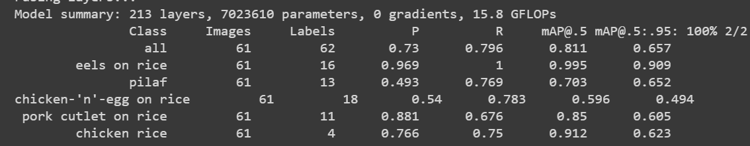

***Confusion Matrix:***

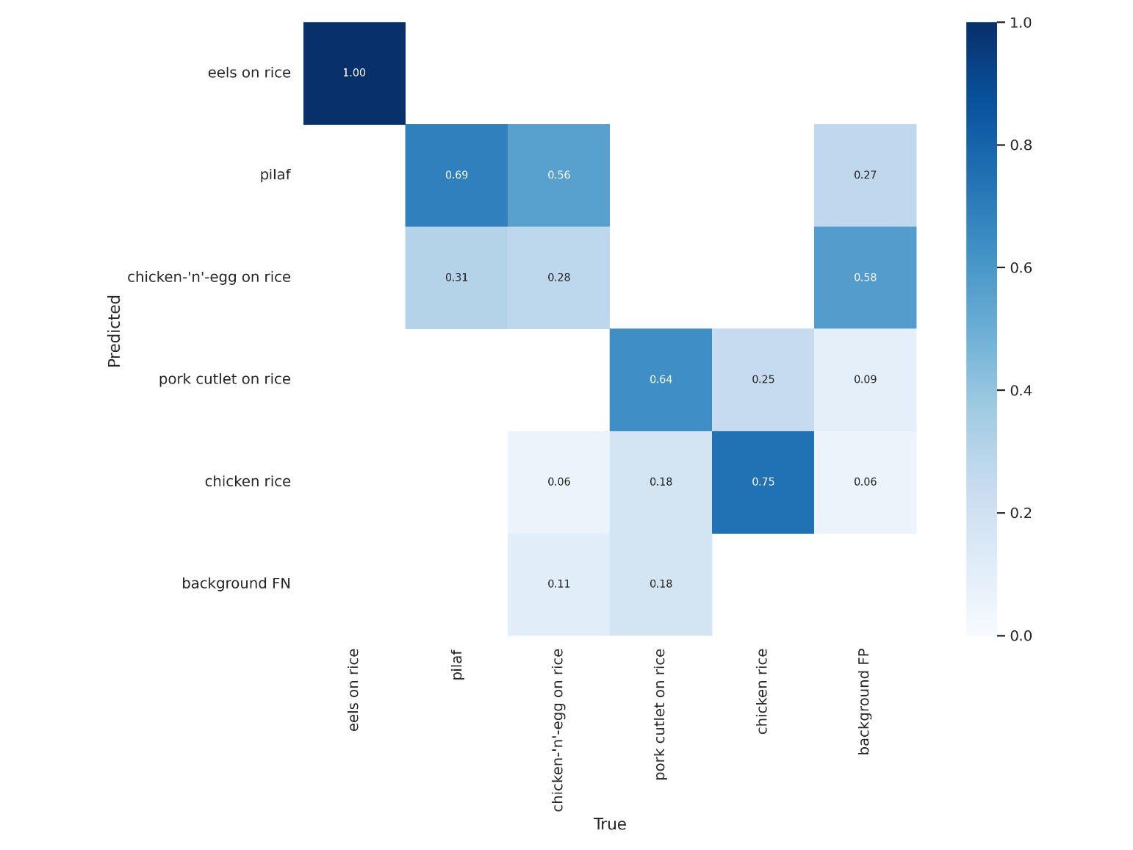

**F1 curve:**

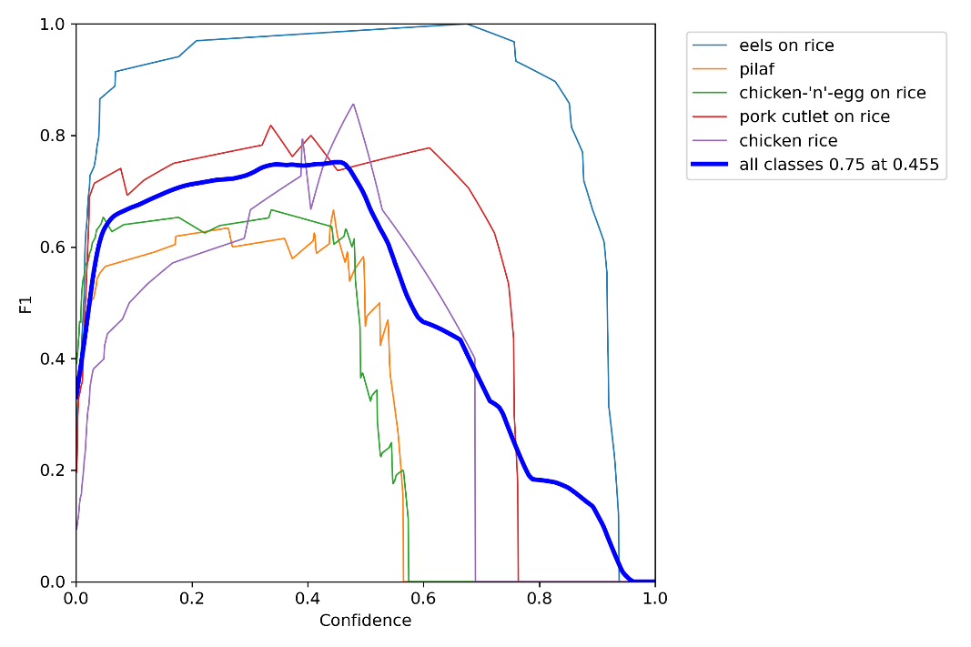

**Precision Curve:**

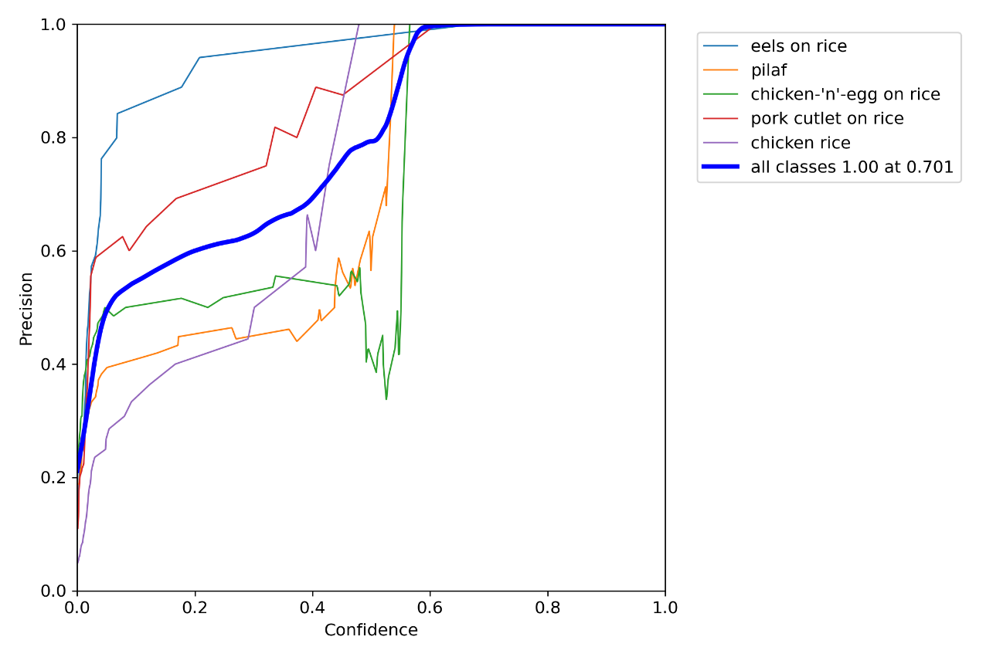

**PR Curve:**

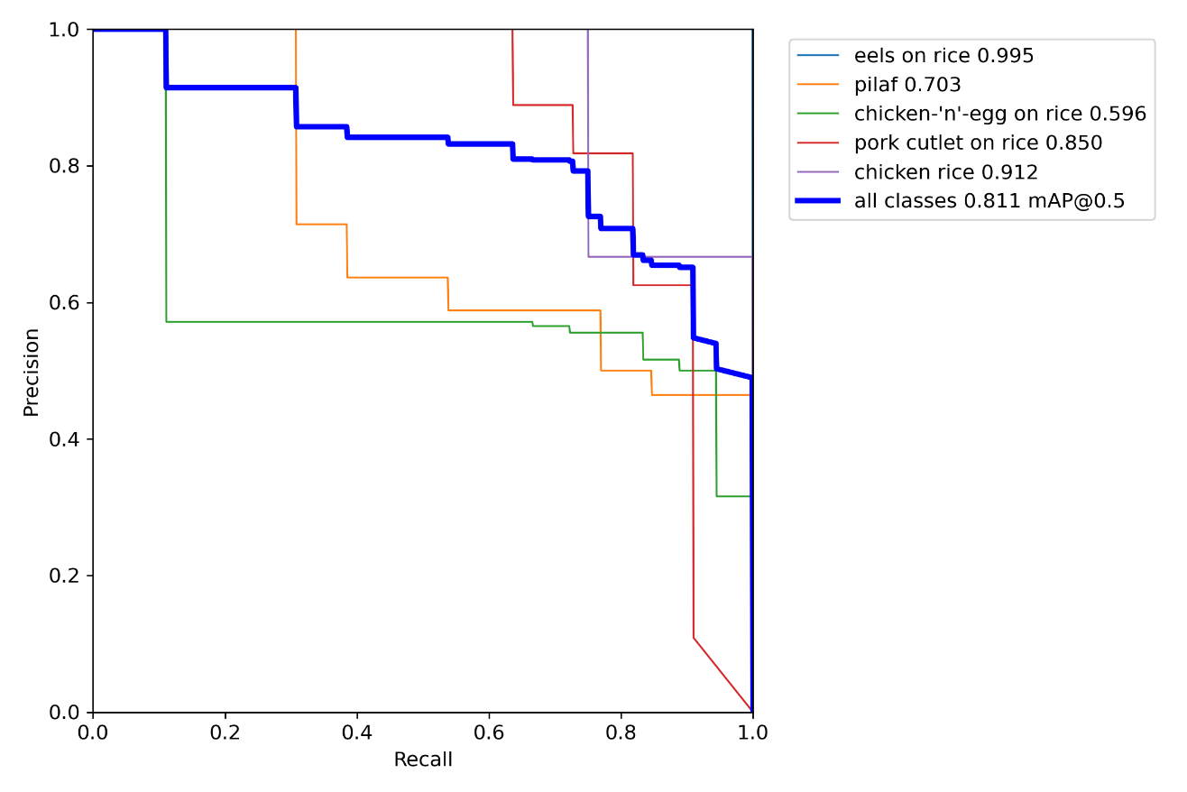

**R Curve:**

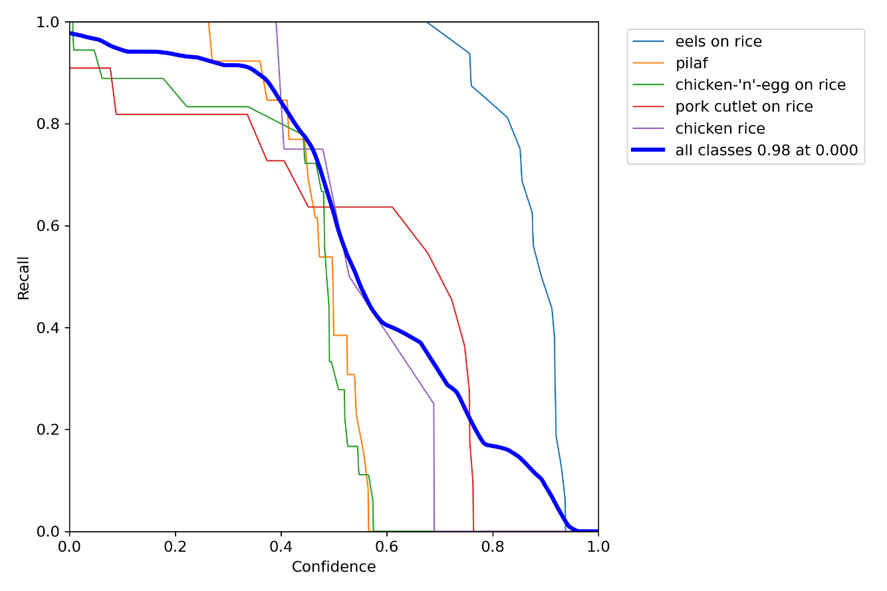

**Graphs (train/val):**

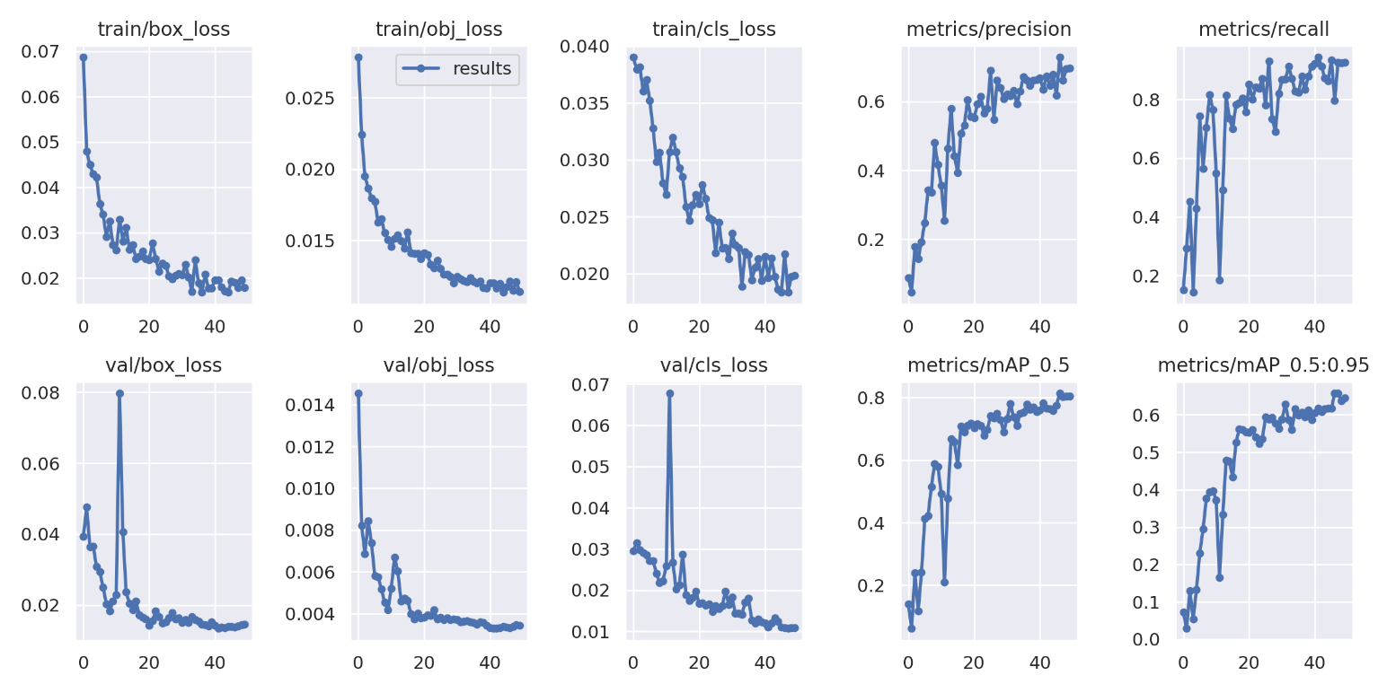

* **Almost 8 out 10 images were detected correctly.**

**Detecto:**

**Loss:**

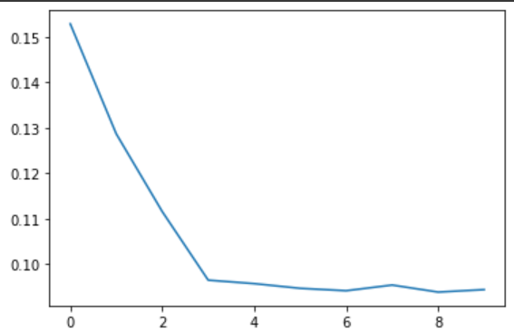

**Last Epoch training:**

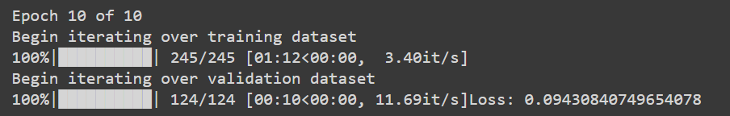

* **Detecto detected 12 out of 15 images (80% accuracy almost).**